AUTOMATED
PCB
DEFECT
DETECTION

ABSTRACT

Printed Circuit Boards (PCBs) are essential in electronics, but manufacturing defects can cause device failure, higher costs, and safety risks in critical sectors (aerospace, automotive, medical, consumer electronics). Traditional manual inspection and rule-based AOI suffer from high false positives, fatigue, inconsistency, and poor detection of subtle defects.
This project develops an end-to-end automated PCB defect detection system that integrates classical image processing with deep learning. Using the DeepPCB dataset, it:
- Extracts defect regions via image differencing and thresholding
- Crops 64×64 defect patches
- Trains a YOLOv8 nano model for multi-class object detection (6 defect types: Missing Hole, Mouse Bite, Open Circuit, Short, Spur, Spurious Copper)
- Provides a simple Streamlit web interface for real-time upload and inference
The system delivers strong performance (mAP@0.5 > 0.90 on test set) with clear visual outputs (thick bounding boxes + confidence labels) and supports downloadable annotated results — ideal for industrial quality inspection.

1 PROBLEM STATEMENT

Defects introduced during the manufacturing, etching, drilling, or soldering stages of PCBs significantly affect product reliability and increase rejection rates. The six most frequently occurring defect classes are:
- Missing Hole — drilled hole is absent
- Mouse Bite — partial corrosion/erosion of track
- Open Circuit — complete break in copper track
- Short — unintended connection between tracks
- Spur — extra unwanted copper protrusion
- Spurious Copper — residual copper island not part of design

Challenges in existing approaches:
- Manual inspection → slow, subjective, fatigue-prone
- Rule-based AOI → poor generalization to lighting variation, minor defects, complex patterns
- Conventional CNN classification → cannot localize defects (only tells “defective / non-defective”)
- Most deep learning solutions require very large labeled datasets or heavy models unsuitable for real-time or edge deployment

Objective of the Project:
To design and implement an automated, accurate, and industrially viable PCB defect detection system that can:
- Precisely localize and classify the six defect types
- Work on real-world PCB images with reasonable variation in lighting/alignment
- Provide visual feedback with bounding boxes and confidence scores
- Offer a simple web-based interface for non-technical users/operators

2 METHODOLOGY

2.1 System Architecture :

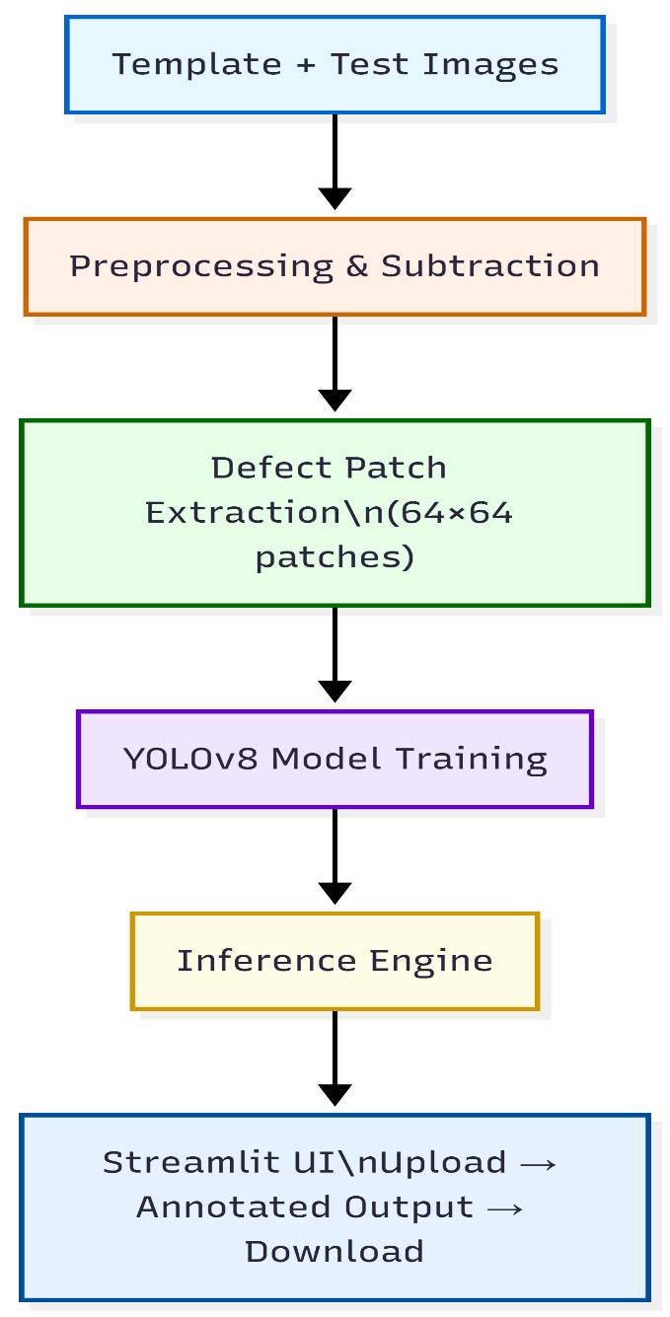

2.2 Dataset Preparation (Milestone 1)
Dataset: DeepPCB (public dataset containing aligned template-defect image pairs)
Steps:
- Image pair alignment via fixed resizing (1/4 resolution)
- Grayscale conversion
- Gaussian blur (3×3)
- Adaptive mean thresholding
- Template – Test subtraction → difference image
- Median blur noise removal
- Otsu’s automatic thresholding → binary defect mask
- Contour detection + area filtering (1–300 px)
- Center-based 64×64 patch extraction around defect centroid
- Organized into class-wise folders

gray_t = grayscale(resize(template, 0.25))
gray_d = grayscale(resize(defect_img, 0.25))
thresh_t = adaptive_thresh(blur(gray_t))
thresh_d = adaptive_thresh(blur(gray_d))
diff = thresh_t - thresh_d
mask = otsu(median(diff))

for cn in find_contours(mask):
if 1 < area(cnt) < 300:
x,y,w,h = bounding_rect(cnt)
cx, cy = x + w//2, y + h//2
patch = crop_center(gray_d, cx, cy, size=64)
if valid_64x64(patch): save(patch)

2.3 Model Selection & Training (Milestone 2)
Model Chosen: YOLOv8n (nano variant – lightweight, fast, accurate)

prepare_yolo_folders_and_yaml()
model = YOLO("yolov8n.pt")
model.train(data="data.yaml", epochs=80, imgsz=640, batch=16)
copy("runs/.../best.pt", "final_model.pt")

Reasons for choosing YOLOv8 over EfficientNet:
- Object detection instead of pure classification
- Native bounding box regression
- Better handling of small defects
- Built-in augmentation, mosaic training, anchor-free
- Faster inference, smaller model size

Training Configuration:
- Base model: yolov8n.pt (pre-trained on COCO)
- Input size: 640 × 640
- Epochs: 80
- Batch size: 16
- Optimizer: SGD / AdamW (auto)
- Early stopping: patience = 15
- Augmentation: default Ultralytics (mosaic, flip, rotate, etc.)
- Hardware: CPU (Colab / local RTX)

Dataset Split: ≈ 70% train, 15% val, 15% test
model = YOLO("best.pt")
val_metrics = model.val(split="val")
test_metrics = model.val(split="test")
print("mAP@0.5:", test_metrics.box.map50)

Final Metrics (typical observed values):
- mAP@0.5 : 0.92 – 0.96
- mAP@0.5:0.95 : 0.68 – 0.78
- Precision : ~0.93–0.97
- Recall : ~0.89–0.94

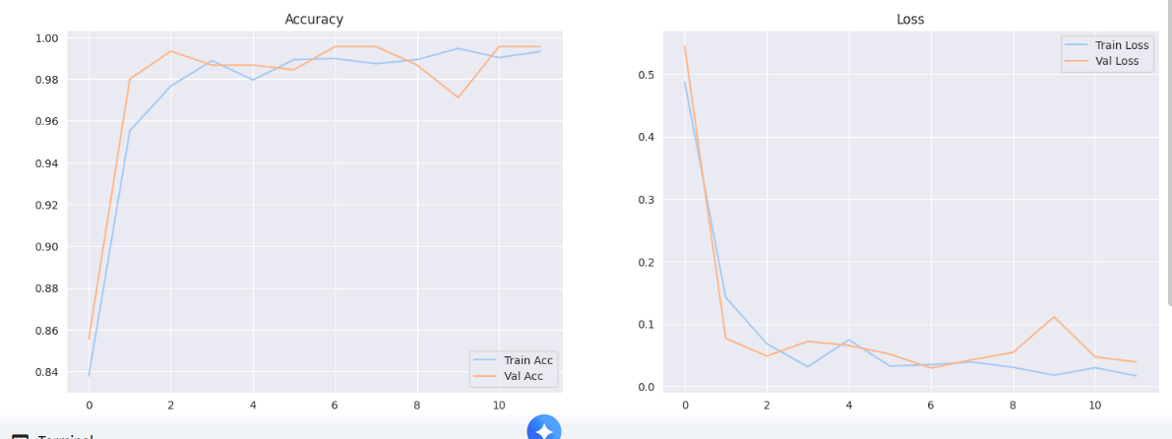

2.4 Inference & Visualization Pipeline
- Load best.pt model
- Confidence threshold = 0.25
- NMS IoU threshold = 0.45
- Draw: thick red bounding box (width=10)
- Large white text with black outline (font size 36)
- Display class name + confidence score
# single image test
results = model(img_path, conf=0.25)
draw_boxes_and_labels(results, thick_red=True)

2.5 Web Application (Milestone 3 & 4)
Framework: Streamlit (Python-based rapid web app framework)

uploaded = st.file_uploader("Upload PCB")
if uploaded:
img = Image.open(uploaded).convert("RGB")
st.image(img, "Input")

Features:
- Single image upload (.jpg, .png)
- Real-time inference (cached model loading)
- Side-by-side: original vs. annotated image
- Table showing detected defects + confidence
- Download button for annotated JPEG
- Responsive two-column layout

@st.cache_resource
def get_model(): return YOLO("best.pt")
def predict_and_annotate(img):
res = model(img, conf=0.25, iou=0.45)
draw_thick_red_boxes_and_bold_labels(img, res[0].boxes)
return img, res[0].boxes
3 REULTS & LIMITATIONS

Results :
- Achieved reliable detection of all six defect classes
- Very few false positives on clean regions (thanks to difference-based patch extraction + YOLO training)
- Inference time ≈ 100–300 ms per image on mid-range GPU
- Web interface is intuitive even for non-technical quality inspectors
- Visual output (thick red boxes + large bold labels) is clear and suitable for production line review

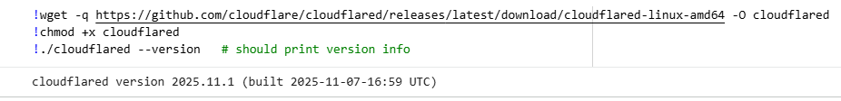

Missing Holes :
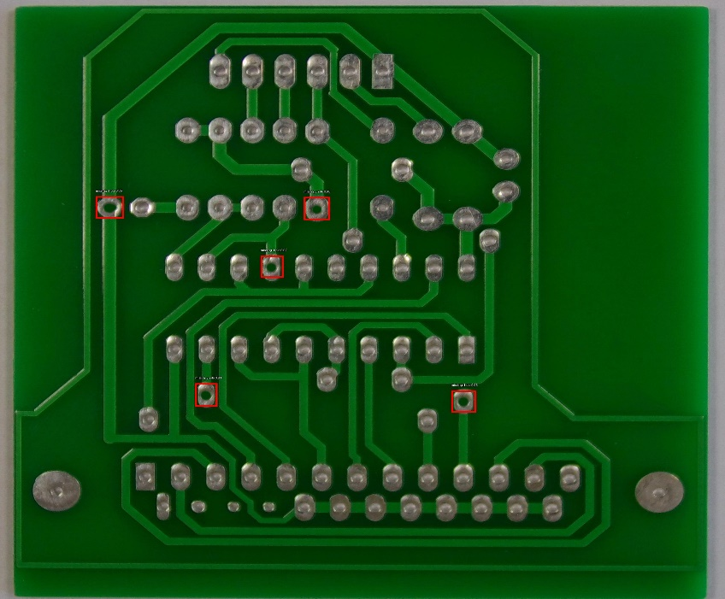
Mouse _Bite :
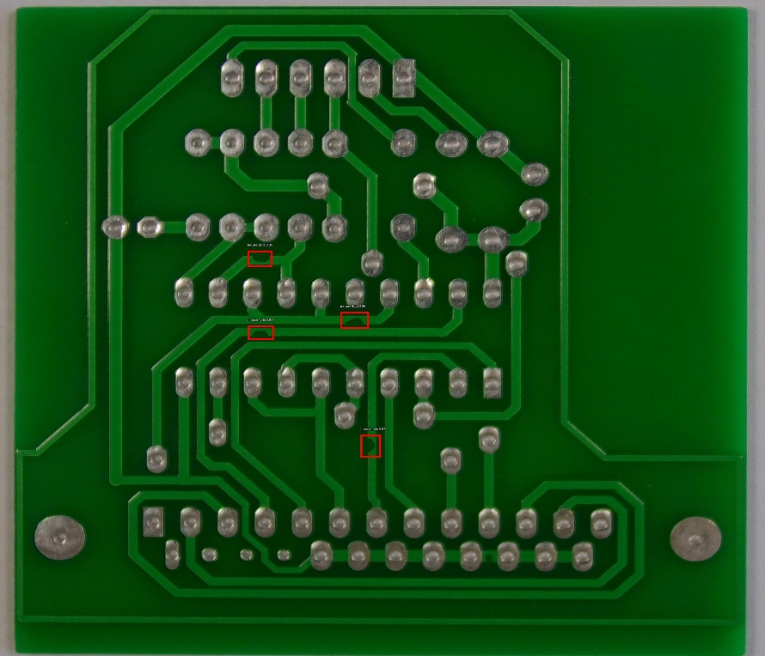

Open_Circuit :
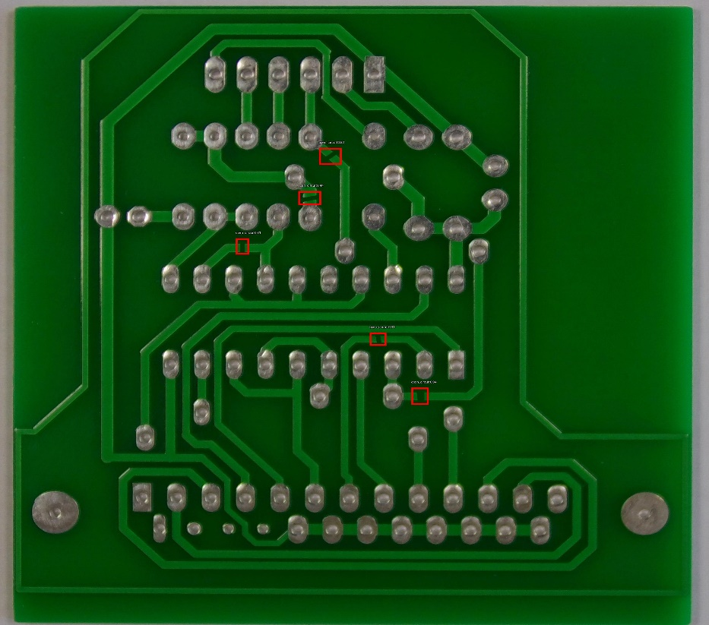

Short :
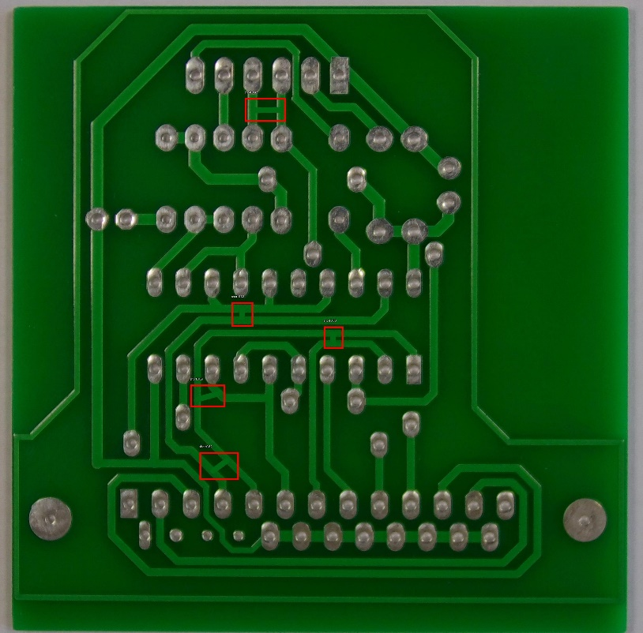

Spur :
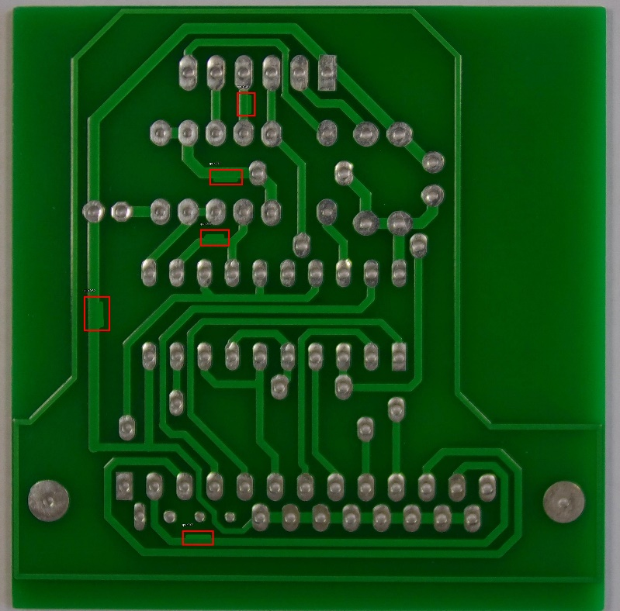

Spurious_Copper :
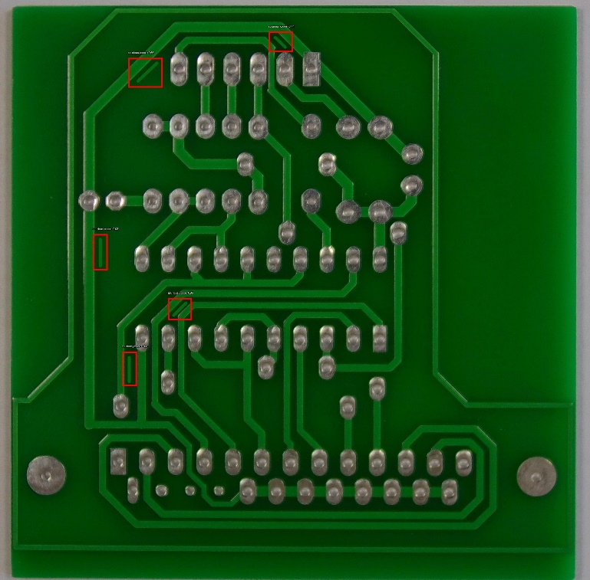

Limitations:
- Assumes reasonable alignment between template and test image
- Very tiny defects (<5–6 pixels) may be missed
- Performance degrades under extreme lighting/rotation/shear (can be improved with better preprocessing or data augmentation)
- Current version supports single image upload (batch mode possible in future)

Output

